A000-PAC-Melanesia-Fiji-Sali Cutting Club, Iron Wood-20th c

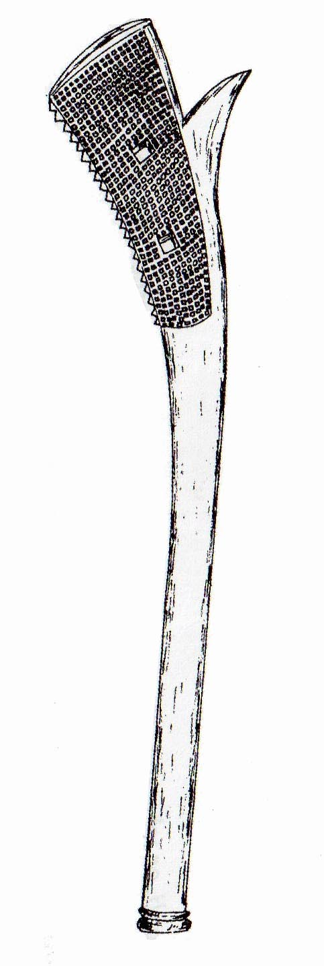

Fig. 1. Melanesia- Fiji-Sali Cutting Club, Iron Wood-20th c

**Case no.: 13**

**Accession Number:**

**Formal Label:** Melanesia- Fiji-Sali Cutting Club, Iron Wood-20th c

**Display Description:**

Fiji-Sali Cutting Club, Iron Wood-20th c, also known as Cali or Tebetebe, these clubs are similar to Gata clubs but they have wider cheeks and a more pronounced spur. They were used in the same way as a Gata with a cutting edge to snap and cut bone. There is a variety of Sali made from a lighter wood made for ceremonial dances. Sometimes ahistorically described as a gunstock clubs, since guns were unknown when these were first made. Typical “kiakavo … dance and ceremonial clubs, [were] rarely if ever used for fighting so lacking a cutting edge – the underside of the head is rounded in the kiakavo, not angled as with the Gata and Sali spurred clubs. Kiakavo were made in a variety of hardwoods and softwoods and a wide range of sizes” (Clunie 1977).

**LC Classification:** GN497

**Date or Time Horizon:** mid 20th c

**Geographical Area:** Fiji

**Maps:**

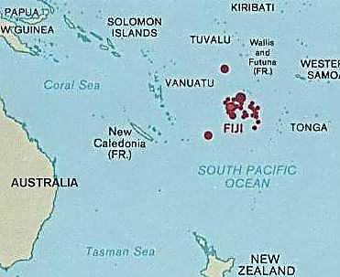

Fig. 2. Location of Fiji archipelago in the western Pacific. After <https://upload.wikimedia.org/wikipedia/commons/a/a8/Fiji_and_oceania.jpg>

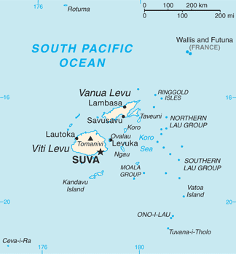

Fig 3. Fiji archipelago. After https://upload.wikimedia.org/wikipedia/commons/e/e1/Fiji_map.png

**GPS coordinates: Suva:** [18°10′S 178°27′E](https://tools.wmflabs.org/geohack/geohack.php?pagename=Fiji&params=18_10_S_178_27_E_type:city)

**Cultural Affiliation:** Melanesian

**Medium:** Iron wood. Raffa twine

**Dimensions:**

**Weight:**

**Condition: original**

**Provenance:** Acquired from Masten Daniel D. Moreland of the Pitcairn Island barque, Picton Castle, when it anchored at Marblehead, Massachusetts, in 2005. 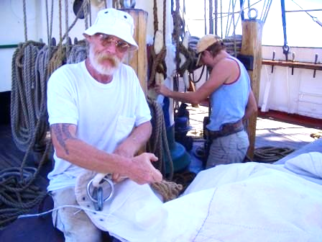 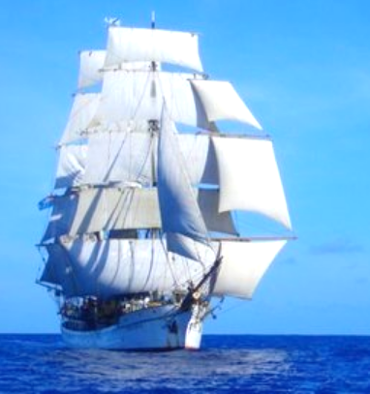

Fig. 4. Master Dan Moreland stitching sails on the course to Bali. After http://www.picton-castle.com/archive/captains_logs/captains-log-pics/2005_11/log66/Morgan_stitching_and_Rebecca_painting_on_the_way_to_Bali.jpg

Fig. 5. The Pitcairn barque**,** Picton Castle, under stun sails. After http://www.picton-castle.com/archive/captains_logs/captains-log-pics/2005_11/log63/Picton_Castle_under_stuns'ls,__on_the_way_to_Bali.jpg

**Discussion:**

Fiji was first settled ca 3500 BCE by Polynesian Lapita peoples.  Lapita pottery shards have been excavated throughout the Fijian archipelago. The warlike Melanesians who migrated to the islands ca 2000 BCE forced many of the Polynesians to migrate to Samoa and Tonga. However, Fijian culture remained a mixture of Melanesians and Polynesians. In fact, canoes made from native Fijian trees have been found in Tonga and Tongan and loan words are part of the language of the Lau group of islands. Fijian ceramics of the Melanesian variety have been found in Samoa and as far away as the Marquesas Islands.

Melanesian Fijians encountered the expeditions of Captain James Cook who met them in Tonga and Cook described them as formidable warriors and ferocious cannibals, builders of fine vessels but not great sailors. All of their manufactures, especially bark cloth and clubs like this one, were highly valued and much in demand. They called their home Viti, but the Tongans called it Fisi.

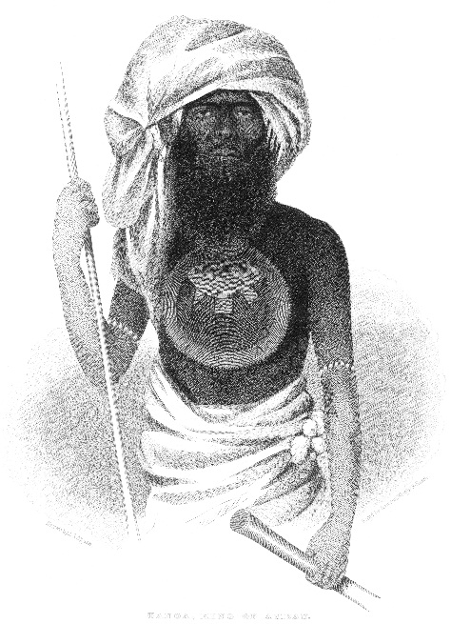 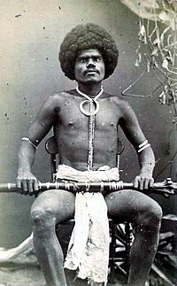 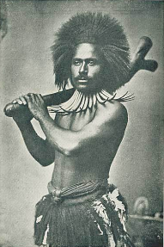

Fig. 6. Tanoa, Melanesian King of Ambau Island, holding a spear used to kill the enemy and a war club, probably a Sali also known as Cali or Tebetebe to snap bone and cut human flesh. These clubs are similar to Gata clubs but they have wider cheeks and a more pronounced spur. Drawn by A. T. Agate, ca 1885. After <https://upload.wikimedia.org/wikipedia/commons/a/ab/Ratu_Tanoa_Visawaqa.jpg>

Fig. 7. Fijian mountain warrior, Kai Colo. *Carte de visite* photograph, 1870's. The subject holds a rootstock club and wears a boar's tusk necklace. After photographer: F.H. Dufty, Levuka, Fiji, 1870’s- <http://www.oceania-ethnographica.com/poly127.html>

Fig. 8. Fijian warrior holding a Sali cutting club. “Missions des Peres Maristes en Oceanie. Un guerrier en tenue de parade. Archipel des Fidji”. Publisher: « sous-procure des missions 6 rue de Bagneux Paris VI ». Ca 1910.

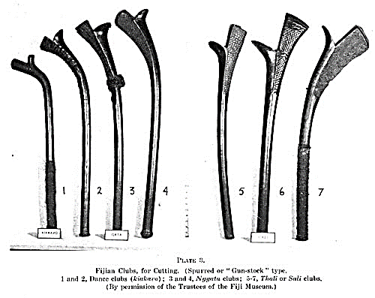

Fig. 8. Types of Fijian Sali war clubs for snapping bone and cutting human flesh. The ones on the left (nos. 1-4) were used mainly for ceremonial dances, being made of lighter weight iron wood. After http://www.jps.auckland.ac.nz/docs/Volume066/images/JPS_066_392insert3_a.jpg

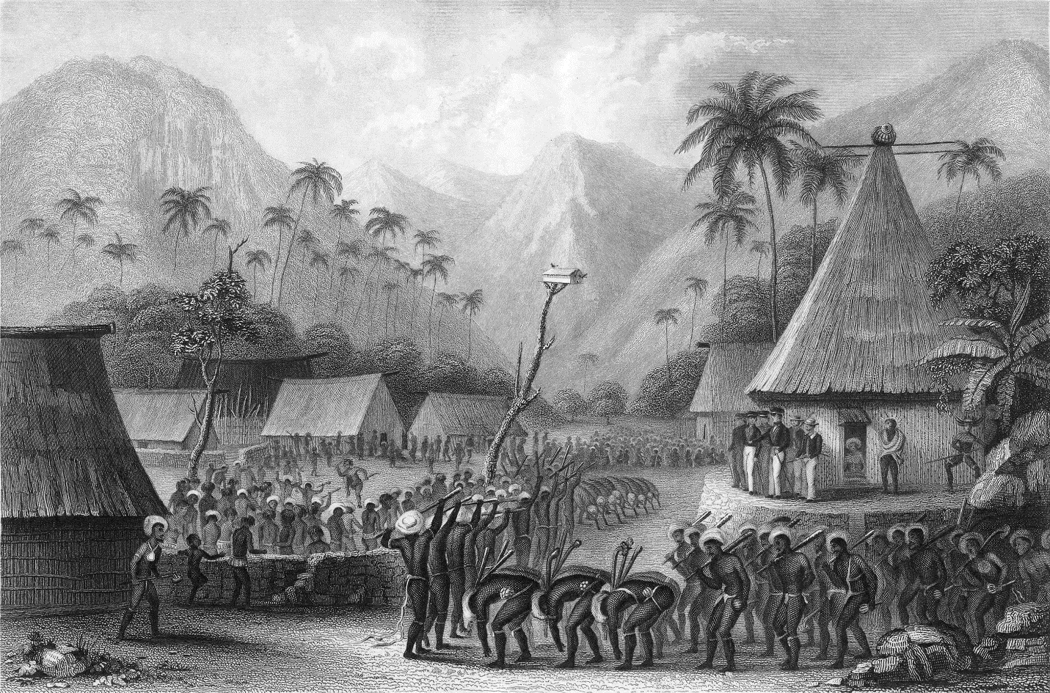

Fig. 9. Scene depicting American sailors being fêted with a war dance.Drawn by Joseph Drayton. Engraved by Rawdon, Wright & Hatch. From Erskine 1896. between pp. 144-145.

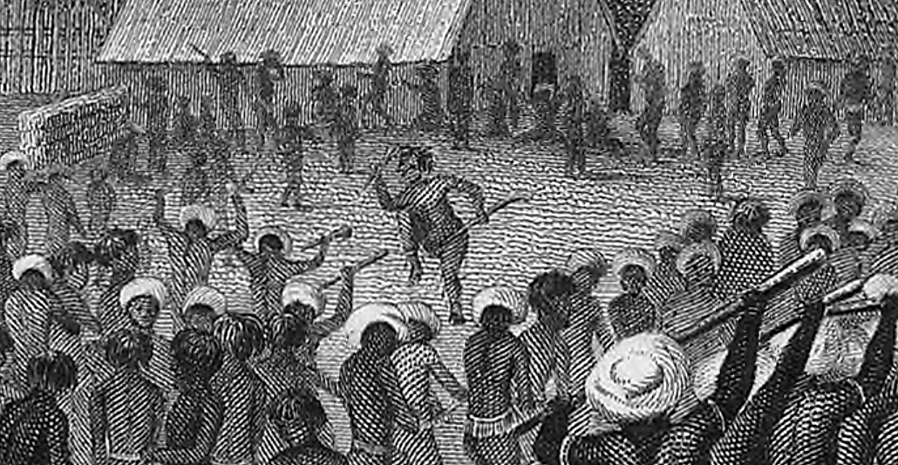

Fig. 10. Detail of a scene depicting American sailors being fêted with a war dance.Drawn by Joseph Drayton. Engraved by Rawdon, Wright & Hatch. From Erskine 1896. between pp. 144-Drawn by Joseph Drayton. Engraved by Rawdon, Wright & Hatch. From Erskine 1896. between pp. 144-145. This war dance involves a single dancer who holds two war clubs, one (an *ulu*) to kill the enemy by throwing, and the other war club (a *sali*) used for snapping bone and cutting human flesh, being performed before an entourage of American sailors who hold their guns ready, knowing that they were out-manned.

The number and variety of Fijian war clubs is testament to the fact that Fiji was beset by a long history of warfare and rampant ceremonial cannibalism. Fijian clubs were the most cherished personal possessions of the Fijian warrior. Fijian clubs that had been successfully use to kill were either inlayed with human teeth or by the cutting of notches on the grip. A club use to kill many enemies was believed to have a life power of its own or *mana*. A Fijian War club with large amounts of *mana* were sometimes placed in a temple to the gods of war, and became ritual objects in funerary rites and certain craft ceremonies.

References:

Beaglehole, J. C. ed. 1961. *The Voyage of the Resolution and Adventure*. Cambridge, England: Cambridge University Press.

Beaglehole, J. C. ed. 1955. *The Journals of Captain James Cook*. Cambridge, England: Cambridge University Press.

Beaglehole, J. C. 1934. *The Exploration of the Pacific.* London: A. C. Black.

Clunie, Fergus. 1977. *Fijian weapons and warfare*. Suva: Fiji Museum.

Erskine, Charles. 1896. *Twenty years before the mast.* Philadelphia: George W. Jacobs & Co.